

California State University of San Marcos

Jordan Fisher, Juan Gonzalez, Keith Gross, Miguel Morales , Noah Miera

CIS490 : Dr. Shaun-inn Wu

### Table of Contents

**Sushi Team - Team Norms** 4

1. **Application development**

1.1 Statement of Business Context 5

1.2 Statement of Customer’s Business Problem 5

1.3 Statement of Project Proposal 5

1.4 Statement of Deliverables 5-6

1.5 Measures of Success 6-7

1.6 System Overview 8-9

1. **Requirements Matrix** 10
2. **Project Management**

3.1 Product Breakdown Structure 11

3.2 Work Breakdown Structure 12

3.3 Initial Schedule for Tasks and Deliverables 13-15

3.4 Statement of Total Cost 15-16

3.5 Gantt Chart 16-19

3.6 Initial Project Cost Tracking Chart 20

3.7 Statement of Deliverables 21

3.8 Outline of Resources Needed 22

1. **Team - Appendix**

4.1 Access to Project 22

4.2 Attendance Records 23

4.3 Future Enhancements 23

4.4 Sprint Meeting Minutes 24-26

4.5 Team Information 27-35

To: Jared Macshane, Machine Learning Supervisor

CC: Dr. Shaun-inn Wu, Director of Projects

The Sushi Team is grateful to be able to be part of this for Keep America Beautiful. Thank you Jared, as well as Dr. Wesley Schultz, for not only this opportunity to work in the Machine Learning field for this project, but also to work on something that helps build and maintain clean, green, and beautiful spaces in America. We have enjoyed working with and learning from you this Spring semester of 2022, in order to assist in the making of this project.

In this final phase, the team aimed towards the final refinement of our system to process and detect litter in Google Street images from a user, for our Machine Learning project for Keep America Beautiful. Such progress so far has led us to the further usage of the YOLOv5 object detection model in our Google Cloud server - with training and testing to detect litter in Google Street images. Additionally, we focused on the finalization of our documentation, and any last modifications needed to our algorithm’s capabilities for both detecting litter, and its compatibility with the Web App team. All information and documentation of the work that was accomplished by the Sushi Team will be available through the GitHub link in the Statement of Deliverables.

Regarding the projected cost of this project, the Sushi Team has determined that we will “charge” a rate of $23 per hour, per member of our team. In this final phase, we had originally estimated to accrue 169 labor hours for a cost of $3,887.00. Currently, we have accumulated a cost of $4,806.24 through 197.76 labor hours, and an accrued cost of $257.76 from our Google Cloud server. With this rate and the currently accrued actual costs of Phases 1, 2, 3, & 4, the total cost of the project came out to a total of $18,371.41, through a total of 780.88 labor hours, and a Google Cloud server cost of $411.17.

By signing below, you hereby approve Sushi Team to continue working on the following project: Keeping America Beautiful: Litter Detective and agree to the aforementioned estimated costs.

From, Team/Scrum Leader: Noah Miera

_________________________________________

*Jared Macshane, Machine Learning Supervisor*

### Sushi Team - Team Norms

● **On time:** Team members will arrive on time. If team members are unable to arrive on time, they will make an effort to notify the team. Absences for emergencies will be excused so long as the team and Professor Wu are made aware of them.

● **Respectful:** Team members will act respectfully towards each other and bullying, harassment, and similar forms of disrespect are prohibited.

● **Willing to learn:** Each team member will be asked to learn new information and skills to complete their work on this project. This learning will both be inside and outside of the classroom.

● **Open to help:** If a teammate is struggling with an aspect of their work, they are expected to ask for help. Similarly when asked for help, team members are expected to assist their teammate so long as they are reasonably able.

● **Communication:** General team communication will be done via the group’s Discord channel.

● **Quality:** Team members are expected to finish their tasks at the best quality possible, satisfying the client. If work is considered poor quality by the rest of the team, it will be redone.

### 1. Application Development

**1.1 Statement of Business Context**

Keep America Beautiful is a leading national nonprofit organization that inspires and educates people to take action every day to improve and beautify their community environment. They envision a country in which every community is a clean, green, and beautiful place to live.

**1.2 Statement of Customer’s Business Problem**

* Need a new Machine Learning algorithm to produce data on Google Street images containing litter.
* Needs the data to not only detect if there is litter, but also categorize them.
* Make the results available and usable for the Web App team.

**1.3 Statement of Project Proposal**

* 1. Process Google Street images through a pre-trained model.
* 2. Adapt model to our specific needs of litter detection.
* 3. Collect output data/results.
* 4. Sync up input/output format with the Web App team.
* 5. Make results accessible to the Web App team.

**1.4 Statement of Deliverables**

* Machine Learning code/algorithm that will be compatible and usable with the Web App team.
* Algorithm will produce data that will include:
  + Identification of litter in an image.
  + The total amount of litter.
  + Show the detection accuracy in testing (e.g. 90% sure this is a Plastic bottle-Litter).
  + *Striving for/Conditional features*:
    - Categorize the litter (e.g. Plastic bottle, Paper bag).

We will strive to deliver a new Machine Learning algorithm for Keep America Beautiful, developed through Python in a Anaconda/Miniconda environment, that will output usable and available results for the Web App team.

**1.5 Measures of Success**

The Sushi Team will perform the following tasks in order to accomplish the requirements listed in the proposal.

* JAD #1 - Identify initial requirements and technical specifications for the project.
  + Connect to a Google Cloud Server.
  + Establish Anaconda/Miniconda environment.
  + Read documentation/code of TACO’s pre-trained model.
  + Collect/Annotate Google Street images for future initial testing.
* JAD #2 - Identify the final requirements and technical specifications for the project.
  + Further collect Google Street images for future initial testing.
  + Establish extra student labor to assist in Google Street image annotations, and the access to software and Google Street images they will need.
  + Research object-detecting pre-trained model options for our detecting litter process.
* Prototype #1 - Process images through the Machine Learning algorithm to produce litter metrics.
  + Fully utilized and integrated the YOLOR object detection model into a Google Cloud server.
  + Trained the YOLOR model with a previous group's Google Street image dataset for litter detection (converted through Roboflow).
  + Wrote a Python script to establish an input/output format, with a TCP connection, for the utilization of the Machine Learning algorithm.
  + Began to look into possible different sources of litter related datasets to better the results of our Machine Learning algorithm for Google Street images.
  + Modified previous group's Google Street image dataset annotations to try to get better results for the algorithms litter detection.
* Prototype #2 - Able to sync up the input/output format of the Machine Learning algorithm with the Web App team, as well as refine the algorithm's litter detection.
  + Fully utilized and integrated the YOLOv5 object detection model into our Google Cloud server. Transitioning from the YOLOR model.
  + Trained the YOLOv5 model with a previous group's Google Street image dataset, re-annotated by us, for refined litter detection. Involved:
    - Tiling Augmentation
    - Hyperparameter Evolution Training
    - Tiny Bounding Box Rejection
    - Test Time Augmentations
  + Modified our Python script to work with our new results, as well as become compatible with the YOLOv5 model, and its latest version.
  + Synced up with the Web App team, establishing a hook with them so that they can use our Machine Learning algorithm, as well as accessible litter metrics.
  + Began working with provided students from Dr. Schultz on a new Google Street image dataset, in order to aim towards the categorization of litter for our Machine Learning algorithm. (Still a work in progress.)
* Final Product - Collation and transfer of litter metrics from images, received by the Web App team, that have been processed through a Machine Learning algorithm, for use by the Web App team.
  + Finalized refinement training for litter detection in the YOLOv5 model, with a new Google Street image dataset, making use of polygon annotations now versus bounding boxes.
    - Involved the same usage of Hyperparamters and Augmentations that we utilized in Phase 4.
  + Finalized our synchronization with the Web App team, pertaining to our algorithms compatibility with their product, and its results.
  + Finalized all of our information and documentation of the work that we accomplished. Made available in our GitHub for anyone that wants a fresh start.

**1.6 System Overview**

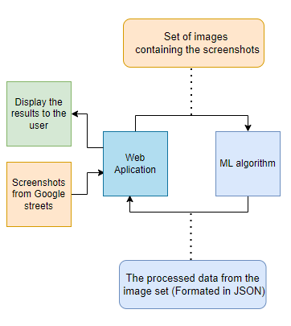

* Closer View of the System - Final Product

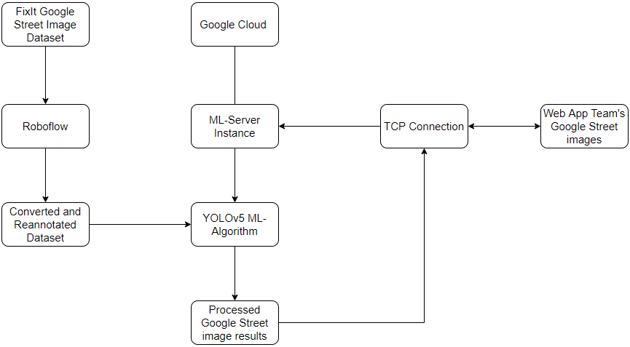

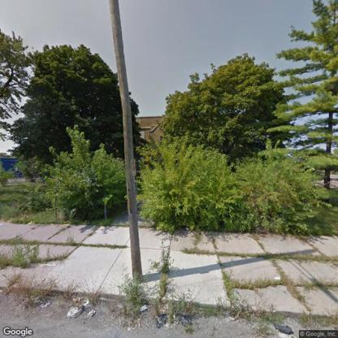







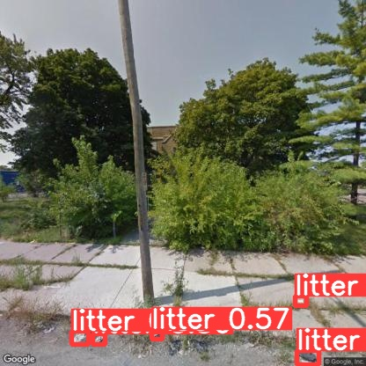 

*(Disclaimer: Cropped images to fit in document.)*

* Currently, we have created a system that can receive and process Google Street images from a user, in which a Machine Learning algorithm will be able to detect instances of litter in the received Google Street images. Once the litter instances have been identified, the system will then output the results into an image with bounding-boxes, identifying the litter, and a JSON file, textualizing the results, for the user.

### 2. Requirements Matrix

|  |  |  |  |  |  |
| --- | --- | --- | --- | --- | --- |
| REQ # | Requirement name | Description | Critical | Implemented | Task ID |
| 1 | Process Google Street images | Google Street image datasets can process through a pre-trained model. | Y | Y | 2.7.1-3.3.1  3.3.8 / 3.3.9  4.3.1 |
| 2 | Litter Detection | The algorithm will identify the presence of litter in Google Street images. Conditional: As well as classify them. | Y | Y | 4.3.7 / 4.5.4  4.5.5 / 4.8.2  5.2.2 / 5.2.3 5.4.4 / 5.4.5  6.2.1 |
| 3 | Prepare Google Street Image Metrics | The Machine Learning program will process the algorithm’s litter results into JSON. | Y | Y | 4.8.8 / 4.8.15 |
| 4 | Send Prepared Metrics | Once the results have been prepared, the program will deliver the metrics to the Web App team. | Y | Y | 5.2.9 / 5.2.10 |

### 

### 

### 

### 

### 

### 

### 

### 

### 3. Project Management

**3.1 Product Breakdown Structure**

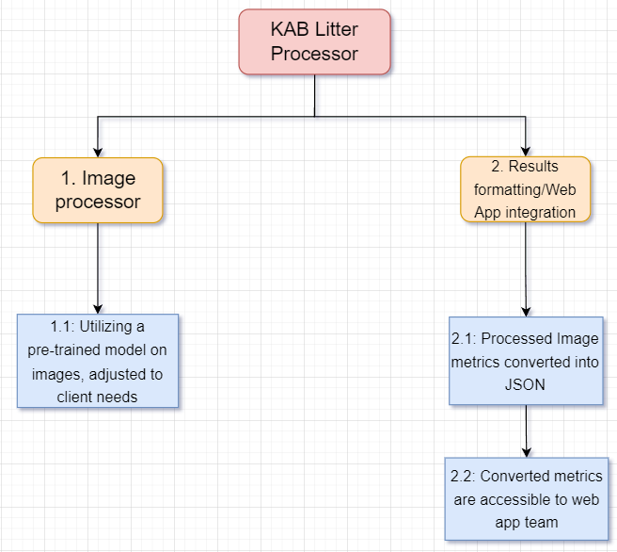

**3.2 Work Breakdown Structure**

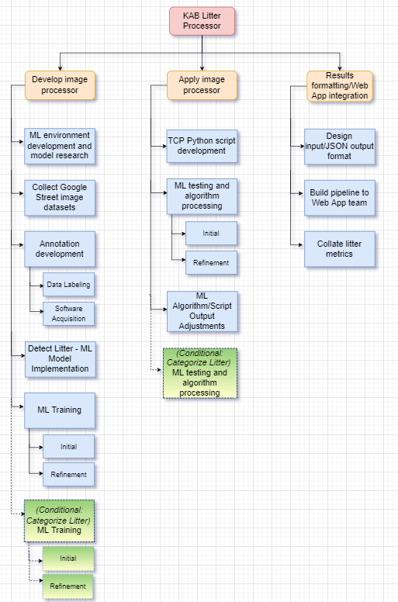

**3.3 Initial Schedule for Tasks and Deliverables**

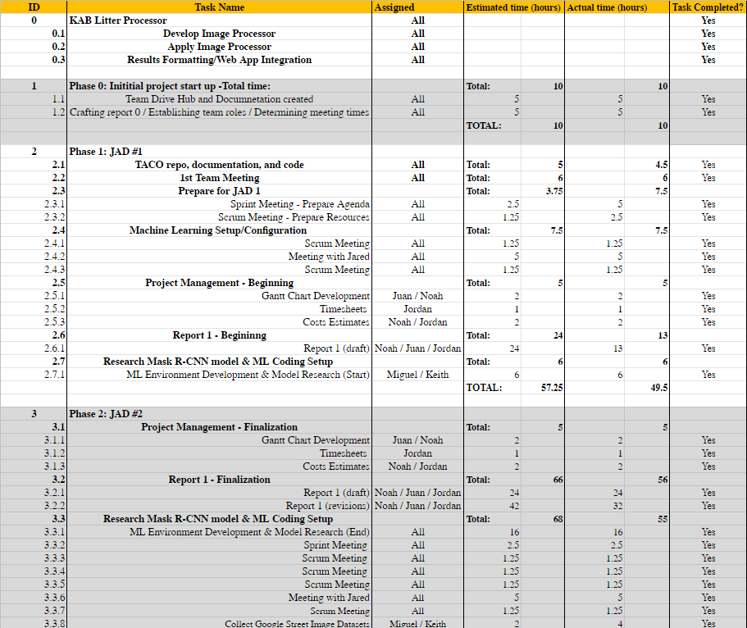

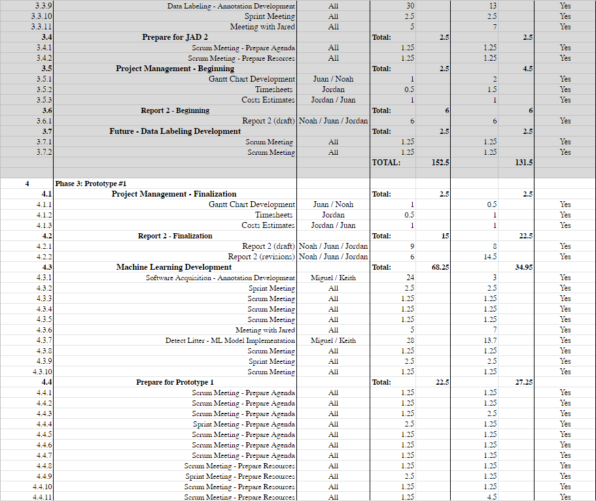

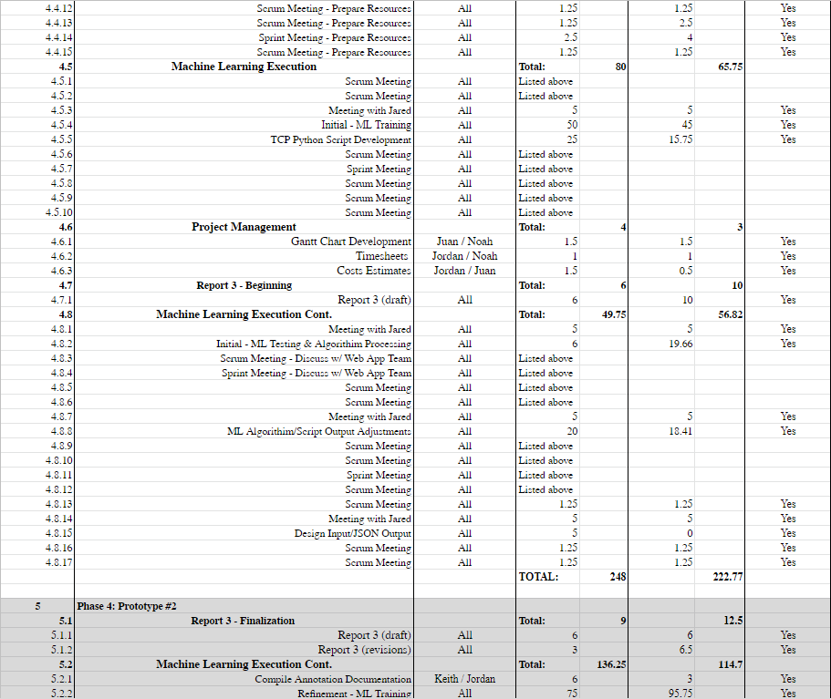

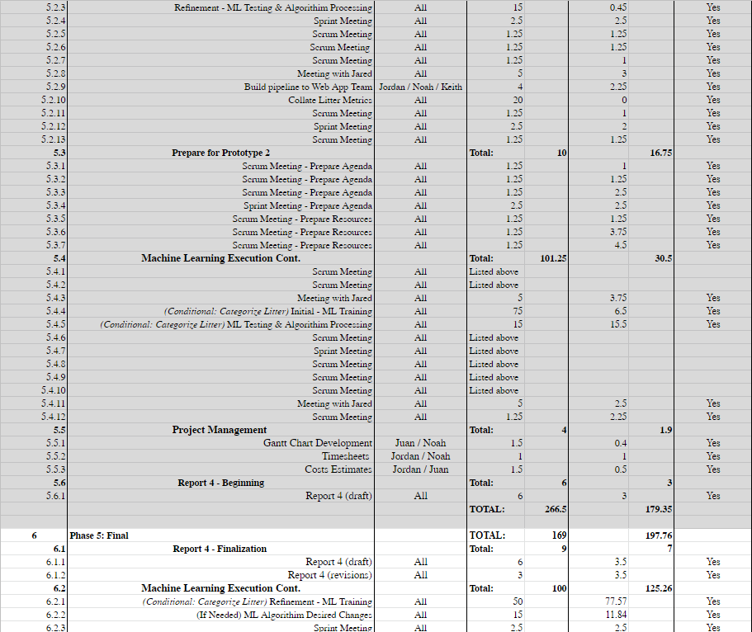

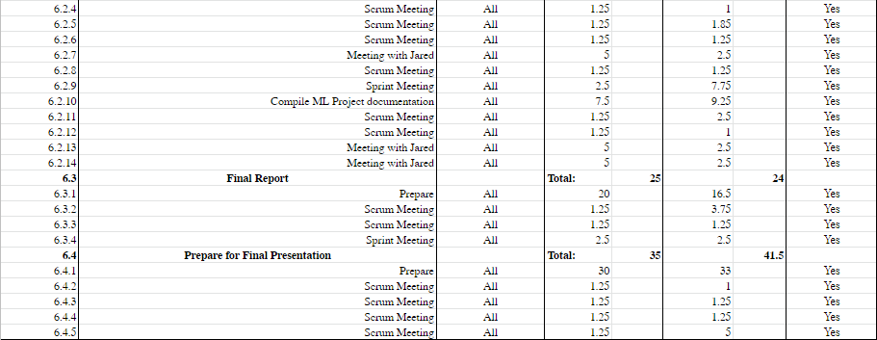

**3.4 Statement of Total Costs**

We will be charging a flat rate of $23.00 per hour for each member of the Sushi Team. The Google Cloud server will cost $0.37 cents per hour to run.

Through phase 1 of the project, it was estimated that the cost will be $1,316.75. This is based on an estimated 57.25 hours of work done by the team in this phase. In actuality, the cost was $1,138.50, having been completed in 49.5 hours of work.

During phase 2, all the members were estimated to work a combined total of 152.5 working hours. As such, the estimated cost for the phase was $3,507.50. In actuality, however, a total cost of $3,024.50 was accrued with a total of 131.5 hours.

During phase 3 of the project, the Sushi Team was projected to work for 248 hours, with a projected cost of $5,704.00 for the phase. In actuality, the team worked a total of 222.77 hours, with a total labor cost of $5,123.71. Furthermore, due to provided discounts & promotions from Google Cloud, we have accrued zero costs from the platform within this phase, during our usage of it.

During phase 4 of the project, the total number of estimated working hours spent towards development amounts to 266.5 hours, with a total cost of $6.129.50. In actuality, the cost was $4,278.46, through not only 179.35 actual labor hours, but also an accrued cost of $153.41 from our Google Cloud server.

During phase 5 of the project, the total number of estimated working hours spent towards development amounted to 169 hours. Thus, the total cost for this phase will be $3887.00. In actuality, the cost was $4,806.24, through not only 197.76 actual labor hours, but also an accrued cost of $257.76 from our Google Cloud server.

Based on our original estimates, the final cost of this project was projected to be $20,544.75, with 893.25 hours spent by the team towards the development of the Machine Learning algorithm. However, when adjusting for the actual hours of the entire project, we found that the actual total cost of the project came out to $18,371.41, accrued over a total of 780.88 labor hours, and a Google Cloud server cost of $411.17.

**3.5 Gantt Chart**

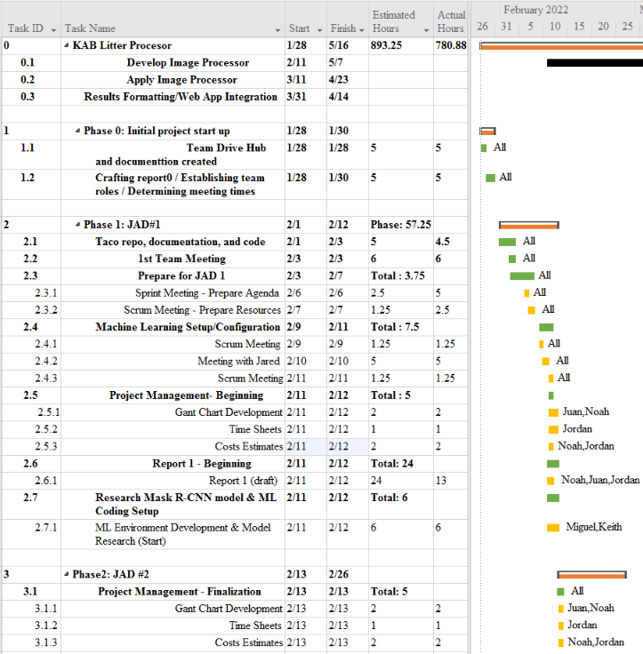

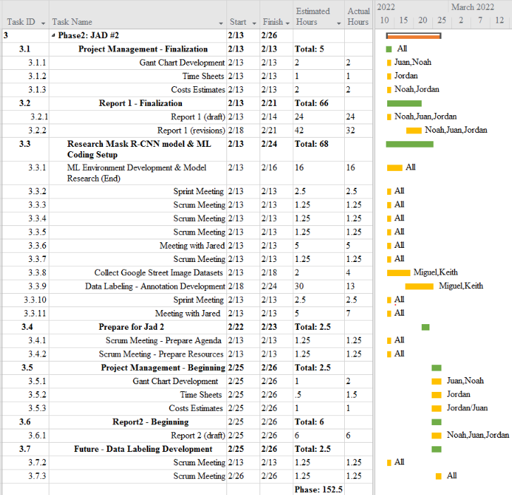

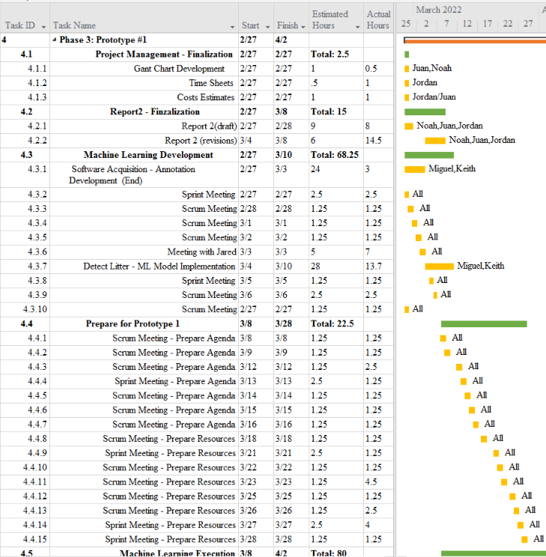

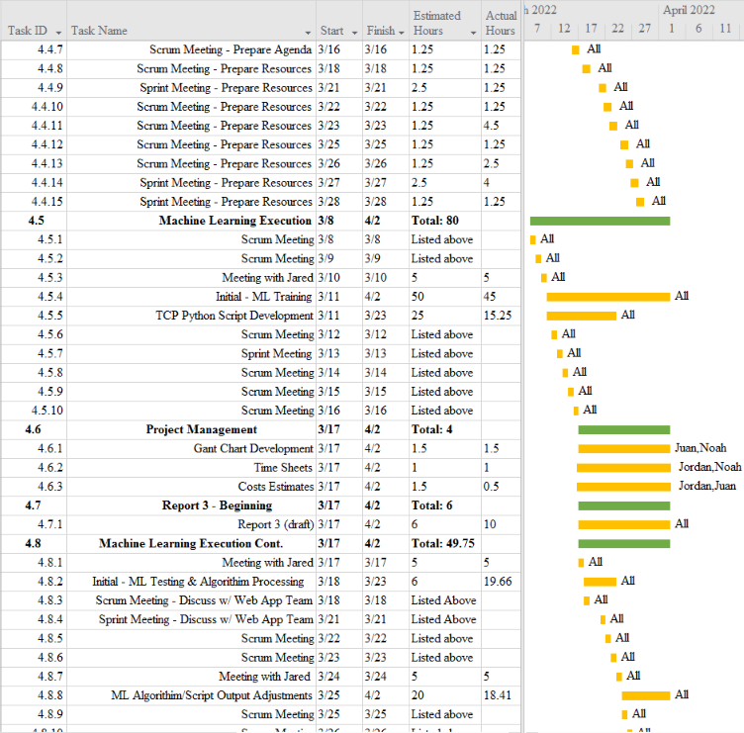

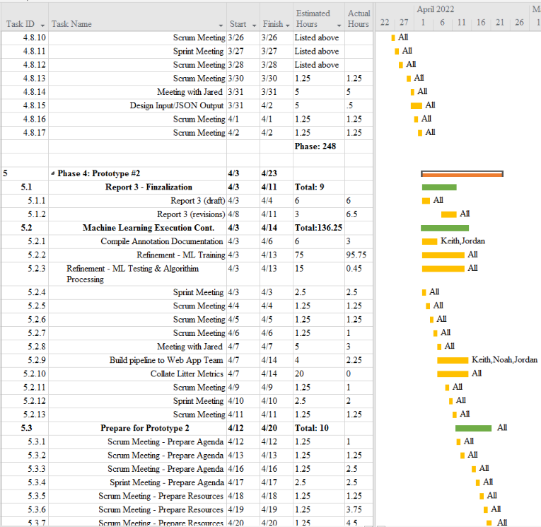

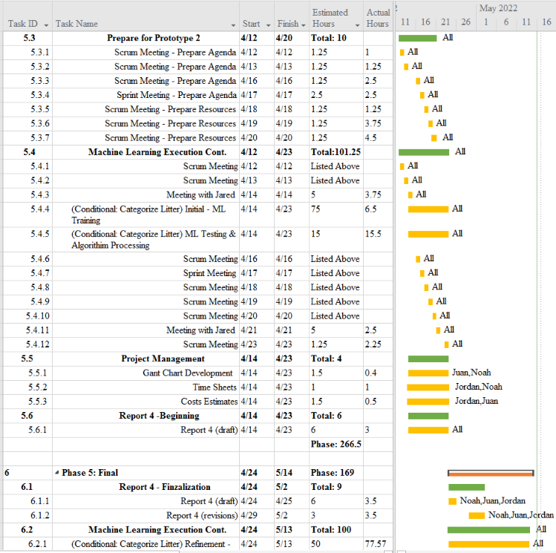

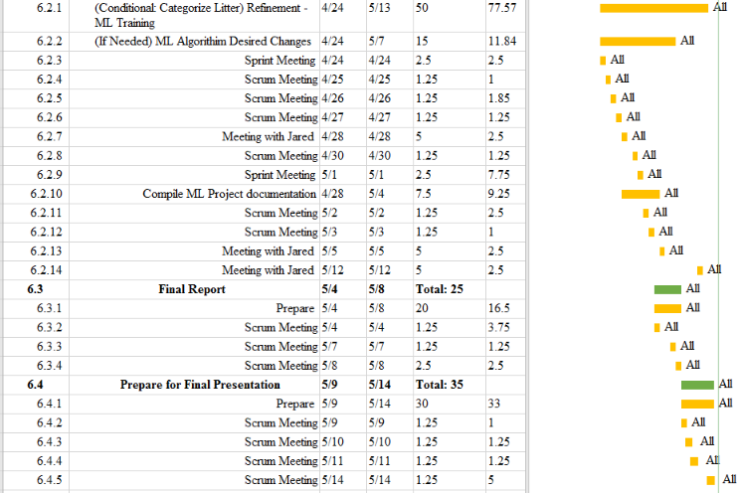

**3.6 Initial Project Cost Tracking Chart**

(As of now, by Phase 5)

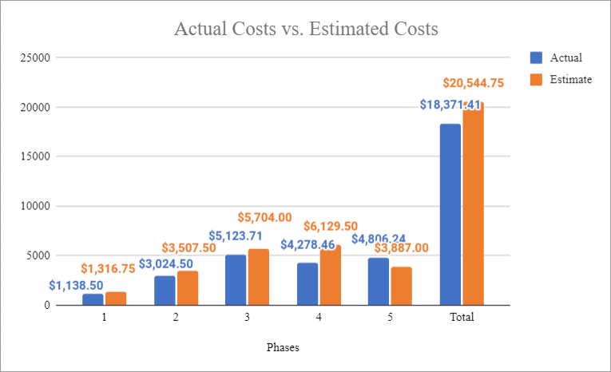

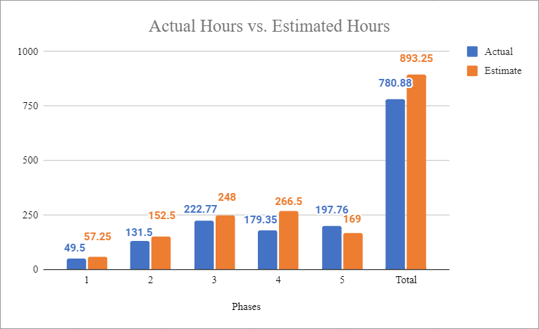

The above chart tracks the estimated and actual costs/hours for each phase of the project as well as our total accumulated costs compared to our estimated costs. Throughout the project we assumed an hourly rate of $23.00 per hour for this project, and we estimate to work a total of 893.25 hours. Phase 4 and 5’s actual costs are a combination of both our actual labor hour costs, and a $153.41 cost of our Google Cloud server in Phase 4, and a $257.76 cost in Phase 5.

**3.7 Statement of Deliverables**

The Sushi Team strives to deliver the following final products:

* The Object Detection Model
  + The latest version of the YOLOv5 Object Detection Algorithm Model, trained by us to detect instances of litter in Google Street images.
* The Algorithm/Scheduling Hook
  + KABML_server.py: TCP Server/Detection code, designed to not only utilize our trained YOLOv5 model, but to also establish a scheduling hook, in which the code will receive & process a set of Google Street images sent from a user.
    - Will output the processed images with bounding boxes around the visible instances of litter, and display the accuracy percentages of each instance, as well as a JSON file to textualize the results.
  + KABML_client.py: TCP Client code, designed to establish a scheduling hook by which a user, such as the Web App team, can use the Litter Detection algorithm, by sending a set of images & receiving their results.
* Documentation
  + Reports and Manuals for users and programmers.
  + Roboflow: A general purpose Machine Learning site, used to generate our Google Street image datasets.
  + YOLOv5: An Object Detection Algorithm Model, utilized for our detection of litter in Google Street images, with certain parameters & augmentations.
  + Google Cloud: A platform we used to train, test, and use our Machine Learning algorithm on, with certain configurations.

All above information is located on the GitHub link located below.

* <https://github.com/SushiTeam2022/KAAB-ML>

**3.8 Outline of Resources Needed**

The following are what the Sushi Team will be supplying:

* Knowledge of Python code, documentation, and implementation.
* Updated documentation.
* Research and testing.

The following resources are what the Sushi Team will need supplied from Jared Macshane:

* References and guidance of Machine Learning through existing models & open-source data/source code/software.
* Google Cloud Server Instance funding.
* Signage and approval for the Sushi Team to continue working on the project.
* Availability for future meetings.
* Possible extra student labor to assist in Google Street image annotations for Google Street image datasets.

### 

### 4. Team - Appendix

**4.1 Access to Project**

The following will be how the Sushi Team will be collaborating during this project so-far:

* Discord.
  + https://discord.gg/XFnssGCw
* GitHUB
  + https://github.com/SushiTeam2022/KAB-ML
* Google Cloud Server Instance.
  + Access is granted by Keith Gross by giving him your SSH public key.
    - gross050@cougars.csusm.edu
  + E.g: ssh username@34.152.63.61

**4.2 Attendance Records**

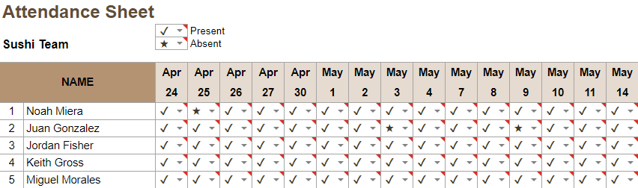

**4.3 Future Enhancements**

The following will be how the Sushi Team believes this project could be enhanced in the future:

* A better dataset.
  + Larger-sized images would allow for better resolution and higher pixel count, which would increase the potential precision of litter annotations. Currently, our dataset represents litter with very few pixels, making variation among litter instances difficult to discern. To this end, a shift from lossy compression jpeg to lossless png images would be a potential area of improvement.
* A new & more fortified annotation process.
  + Based on our experience with Roboflow, while the site was useful, full control of a workspace is easily accessible to any member of a project, even if they are a temporary member. Additionally, the site itself seems to be loosely monitored at the present time, as more users than officially stated by the site's rules were able to join within a Free-tier workspace. These issues may be fixed in the future.
* More GPU.
  + Additional GPUs would speed up the overall process, though costs would increase accordingly.
  + The introduction of multithreading processing would allow more than one process to run concurrently, to allow more users/litter detections at once.
* Expand the litter detection algorithm to assess more litter types.

**4.4 Sprint Minutes**

Sushi Team Sprint #12 Meeting Notes

Sunday, 04.24.2022

# **Attendees**

Noah Miera: Team/Sprint Leader

Juan Gonzales: Project Manager

Jordan Fisher: Documentation/Training

Keith Gross: Programer

Miguel Morales: Programer

# **Minutes:**

## 12:00 PM: Discussion of training

* Training started, but results are not ideal
* Trained for 6 hours last night, training ongoing today.
* Server costs for this phase have been $41.45 +$111.96 = $153.41at $0.37/hour

## 12:13 PM: Review of future direction

* Final Phase has 2 main tasks
  + Continue training (Done by May 7th)
  + Categorize litter
* Training is currently being done on a merged dataset with collapsed categories
* New super parameters will most likely be used for this latest batch of training
* If Dr. Schultz’s students get us enough images annotated then we will attempt to go forward with the categorization training
* Categorization training may take up the first week of May

## 12:22 PM: Review of updates needed for Report 4D

* Fairly standard, update phase with new info from phase 4
* Add bar to graph tracking the google cloud costs as they are distinct from labor costs
* Statement of deliverables

## 12:35 PM Meeting adjourned!

Sushi Team Sprint #13 Meeting Notes

Sunday, 05.1.2022

# **Attendees**

Noah Miera: Team/Sprint Leader

Juan Gonzales: Project Manager

Jordan Fisher: Documentation/Training

Keith Gross: Programer

Miguel Morales: Programer

# **Minutes:**

## 12:00 PM: Discussion of training

## 12:07 PM: Discussion of the suggested changes for 4D

* Figure out changes to statement of tasks
  + (Long discussion over how to implement)
* Project breakdown structure has been adjusted per Project Director’s feedback

## 1:00 PM Meeting adjourned!

Sushi Team Sprint #14 Meeting Notes

Sunday, 05.8.2022

# **Attendees**

Noah Miera: Team/Sprint Leader

Juan Gonzales: Project Manager

Jordan Fisher: Documentation/Training

Keith Gross: Programer

Miguel Morales: Programer

# **Minutes:**

## 12:00 PM: Discussion of completed training

## 12:05 PM: Review of documentation

* Requirements documentation completed
* ReadMe and roboflow documentation underway

## 12:10 PM: Discussion of future training/dataset usage

* Training will continue, and we will be checking in with Jared

## 12:17 PM: Confirmation of documentation

## 12:35 PM Meeting adjourned!

## 

**4.5 Team Information**

|  |  |
| --- | --- |
|  | Noah Miera  Team/Scrum Leader  While I do not have experience working in Machine Learning, or Object Detection before, I do have experience working in Python, the language for this project, according to Jared. I believe I will work well as Team/Scrum Leader, due to me being in similar positions for other past school projects, non-school events, and work. I will strive to maintain continuity and consistency throughout this project. |
|  | Juan Gonzalez  Project Manager  I have worked on two machine learning based projects in the past where I understood that cleaning up a data set is essential to acquiring desired outcomes. I’ve solely worked with numerical data when implementing machine learning and have not worked with image processing. My experience working with Sushi Team as Project Manager has involved high amounts of communication among the team in order to organize and manage tasks to meet requirements. Taking advantage of modern Project managing apps will be key to our success. |
|  | Jordan Fisher  Documentation/Training  My primary contribution to the Sushi team is ensuring that the team lead and project manager have access to clean organized information and creating accurate and descriptive diagrams to better communicate said information. In my scholastic and professional life I have filled similar roles such as in the numerous group projects where I took on such responsibilities. |

|  |  |
| --- | --- |
|  | Keith Gross  Programmer  My background working in Test Engineering and the U.S. Navy has provided me with the skills needed to develop solutions for complex problems I may not have a background in. While I don’t have a background in Machine Learning I am able to find the resources we need to develop our machine learning algorithm and program, program a solution, then resolve any issues that present themselves during our test cases. |
|  | Miguel Morales  Programmer  Miguel Morales is a programmer for Sushi Team. Mr Morales has experience in several programming languages such as C/c++, Java and Python. The programming role is well suited because of his adaptability skills to learn and approach computer problems. |

**Resumes**



